Green Society Public School
D-23
Ratnanagar-7, Sauraha, Chitwan
Third Terminal Examination-2082
Class: UKG Time: - 2 hrs. F.M.: 50
Sub: Project Work
Name: Roll No.: Sec.:
________________ ______________ OBT.MARKS:
INVIGILATOR EXAMINER
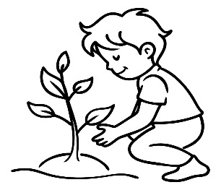
- Tick (√) for good behaviour and cross (x) for wrong behavior. (4)
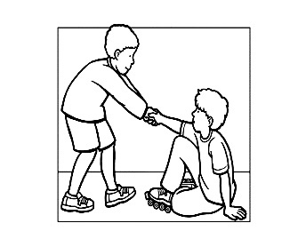

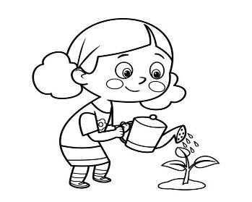
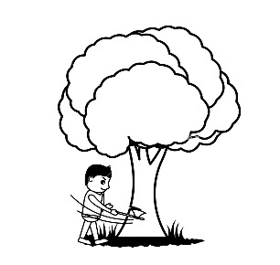

- Complete the picture by drawing other half part. (4)
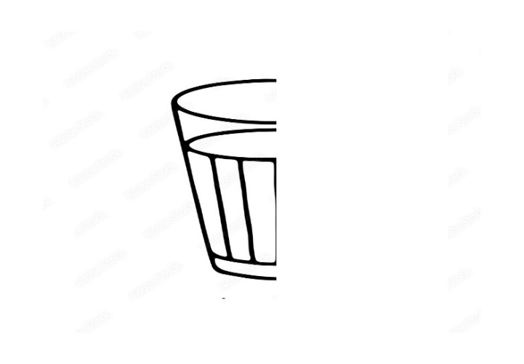 | 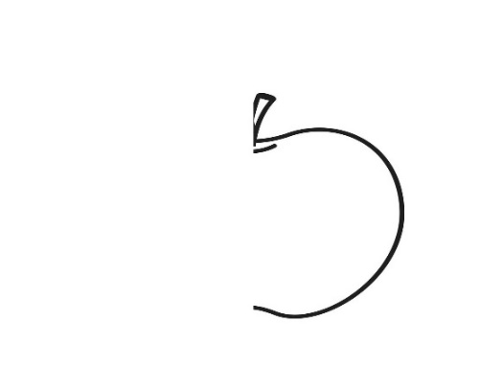
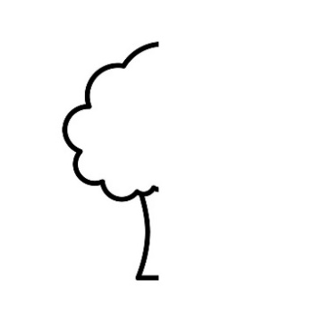 | 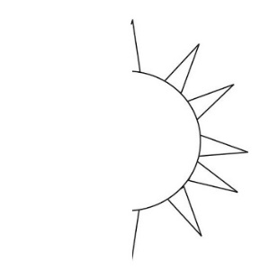
- Match the following with their name. (6)
Play ground | 
library | 
classroom | 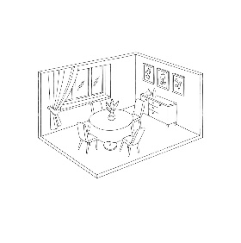
dining hall | 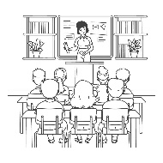
office | 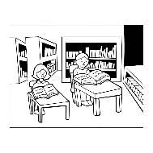
reception | 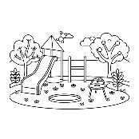
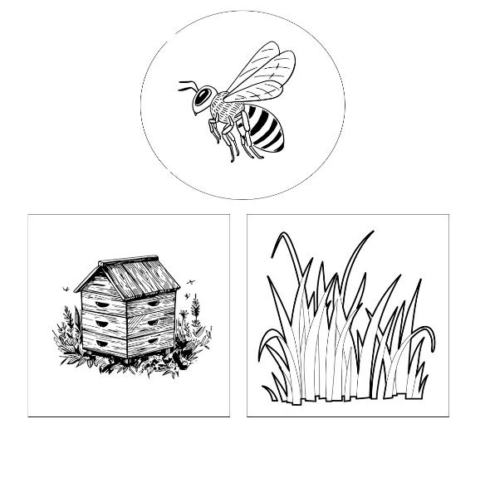
- Look at birds and insects and colour their correct homes. (6)
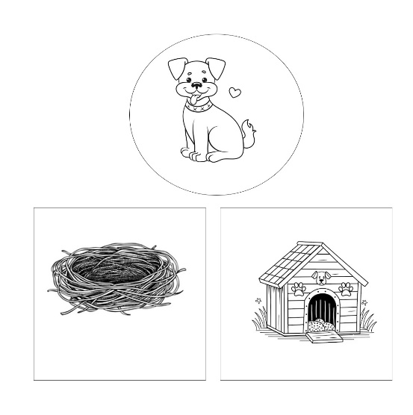

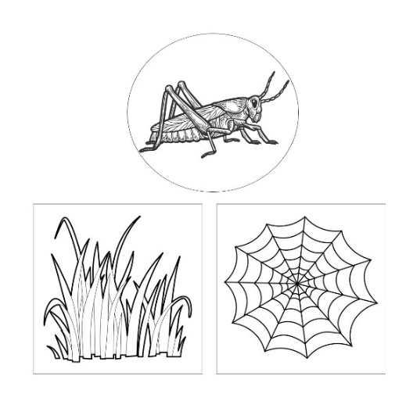
- Look at the picture and write 'Whole', 'Half', 'quarter'. (6)
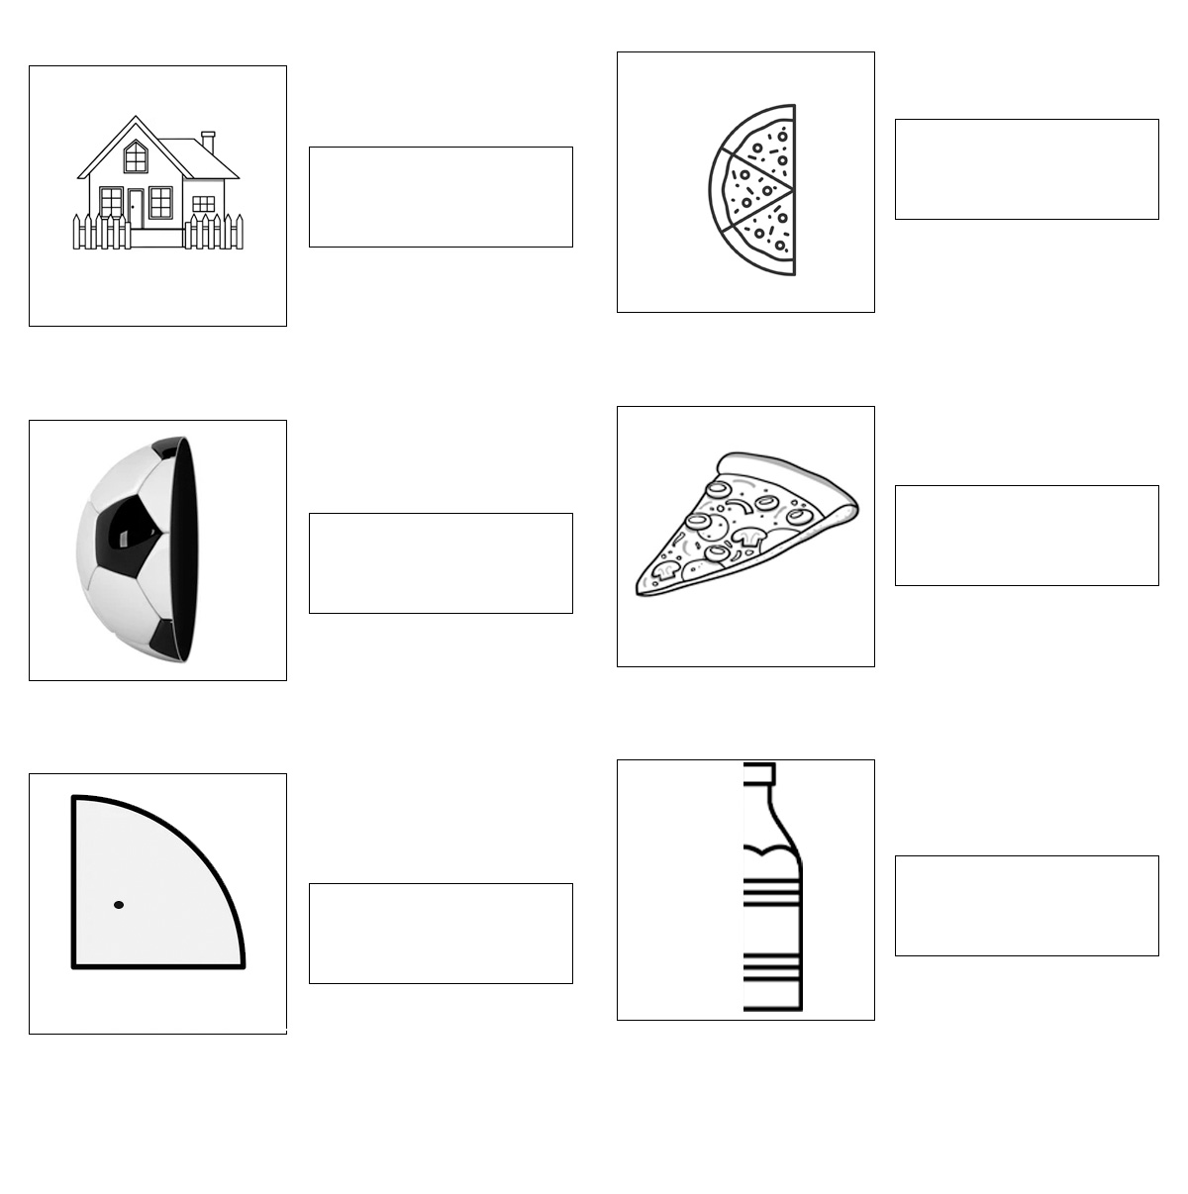
- Colour the traffic light and write about it with the help of key words. (7)
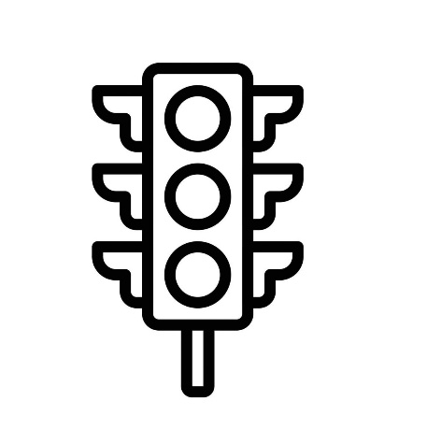 | Red light says ………………  Yellow light says……………  green light says……………..
- Draw the picture of best vehicle. (7)

- Colour the picture. (10)
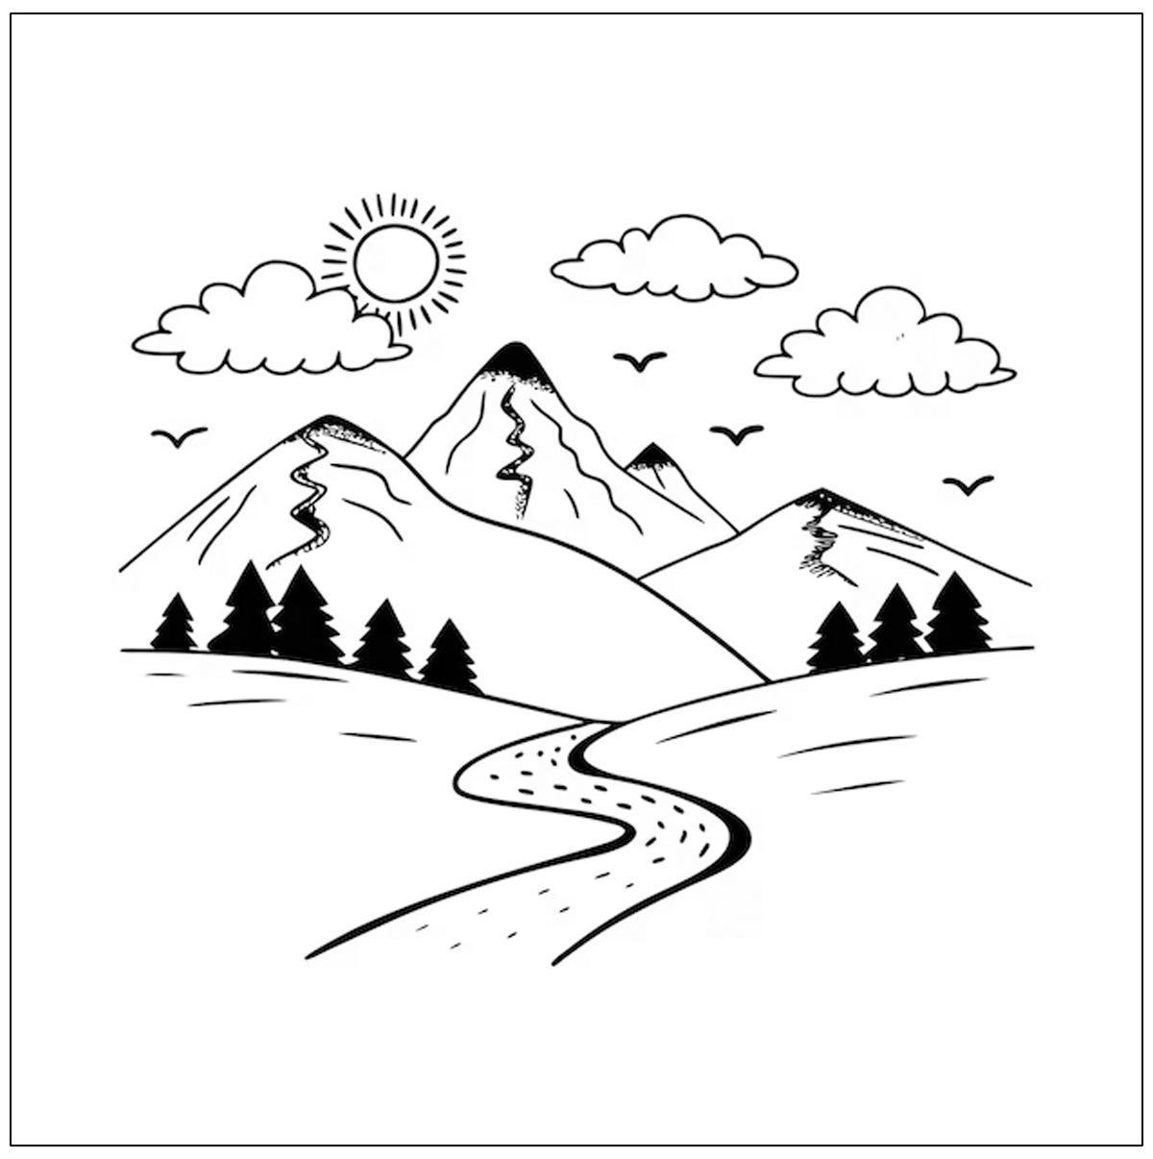

The End

